17.91: a) 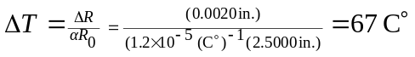 to two figures, so the ring should be warmed to 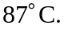 b) the difference in the radii was initially 0.0020 in., and this must be the difference between the amounts the radii have shrunk. Taking 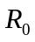 to be the same for both rings, the temperature must be lowered by an amount
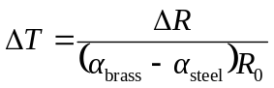
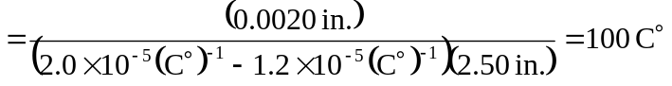
to two figures, so the final temperature would be 